**NAME: Davronov Dilshodbek**

**Student ID: B2005499**

**Date of Submission: 24.11.2020**

**Testing Report**

**Creating Appropriate Folders.**

I created necessary files for project.

1. CSS folder > style.css

2. Fonts > text

3. Images > pictures

4. Index.html , about.html , work.html , contact.html

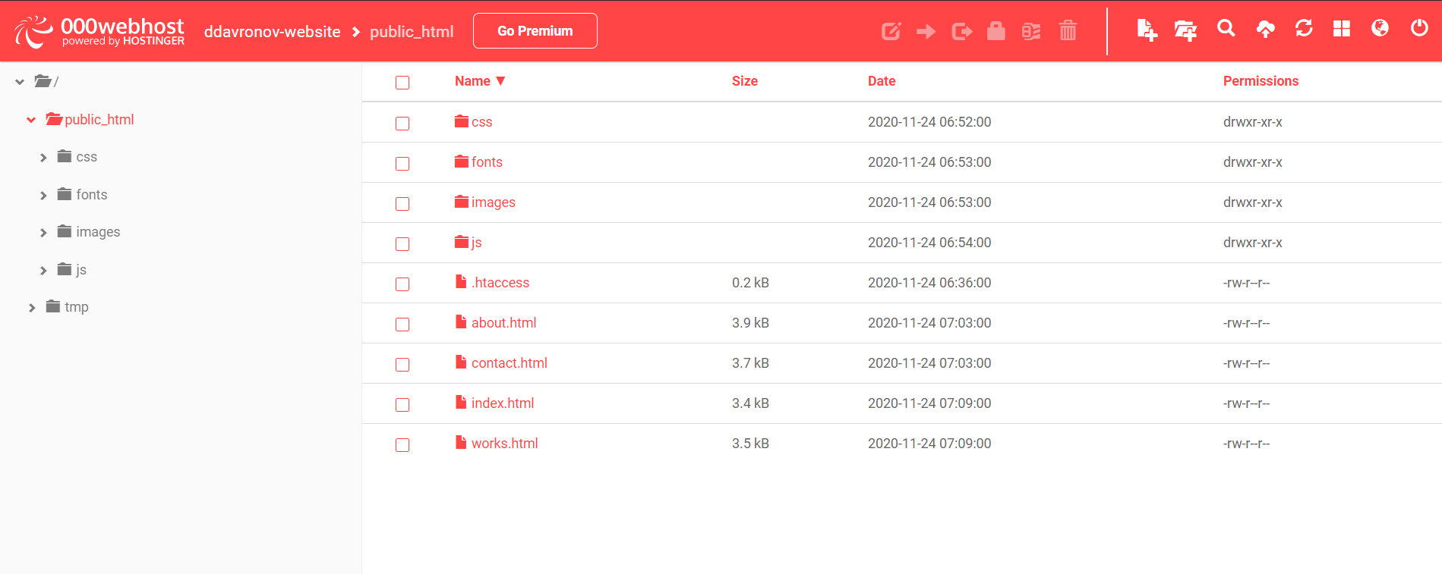

**- Part of the Website**

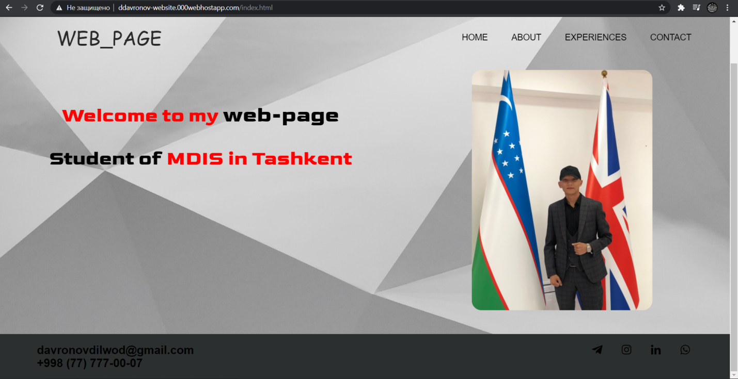

**- Index.html**

This is **index.html** folder. I put some necessary links, meta and title on the pair tag **<head>.** Links such as boxicon.com connected in order to get icons. Initially all of the necessary CSS files and JavaScript files were declared in the head section of the webpage. I connected style.css through tag **<link>** in HTML and wrote the way of style.css. Because of my style.css placed on the CSS folder I wrote **css/style.css.**

See figure below:

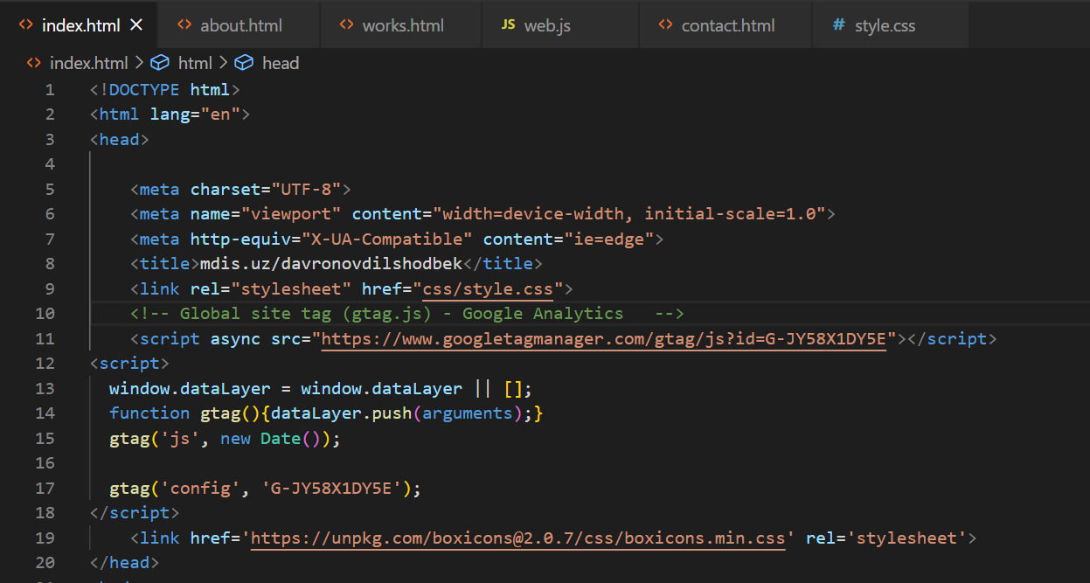

* **Body part, Navigation Bar**

The next division of the page is the Navigation Bar, all the links to navigate the content of the page are listed here.



So I have created “**class**” in order to have access and manipulate elements with the specific class name, and created **div** with wrapper class for the **right padding** in the site. Navigation on the header The **<nav>**tag defines a set of navigation links, which is created on HTML5 and more valid. I have divided the content on the left and right sides on the pair tag **<nav >.** First one is logo, created by pair tag <a>, second side is menu list, constructed by pair tags **<ul>, <li>** inside **<ul>** and **<a>** inside **<li>.** The **href** attribute specifies the URL of the page the link goes to. For instance, in the 29th line I have written **href**=”index.html”, I have transferred to the index.html folder by pressing word Home.

See figure below:

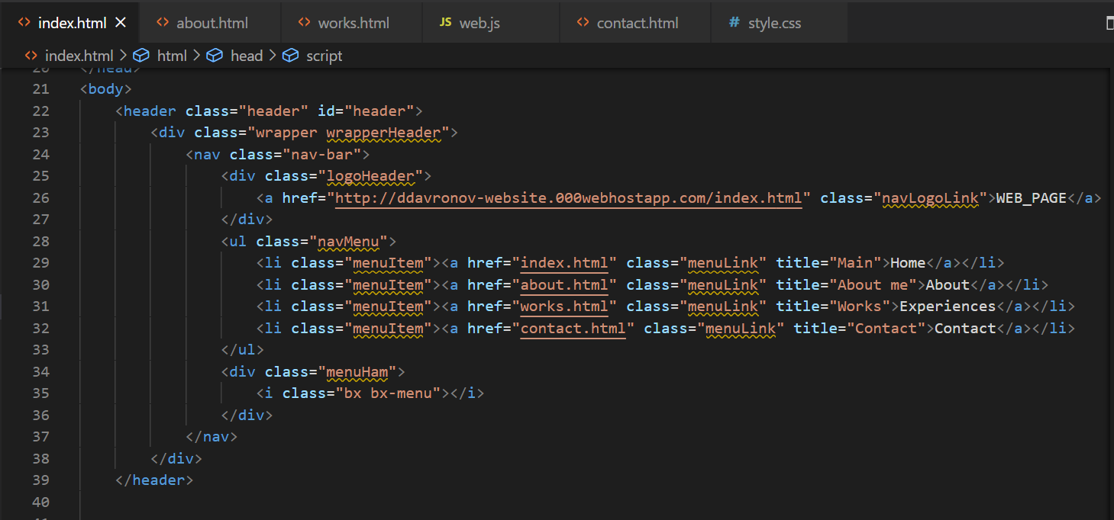

I added my photo using :

 <img src="images/374.JPG" class="model" alt="model">

with class in order to styling in CSS



* **Footer**

The **<footer>** tag defines a footer for a document or section.

Here is my footer section:



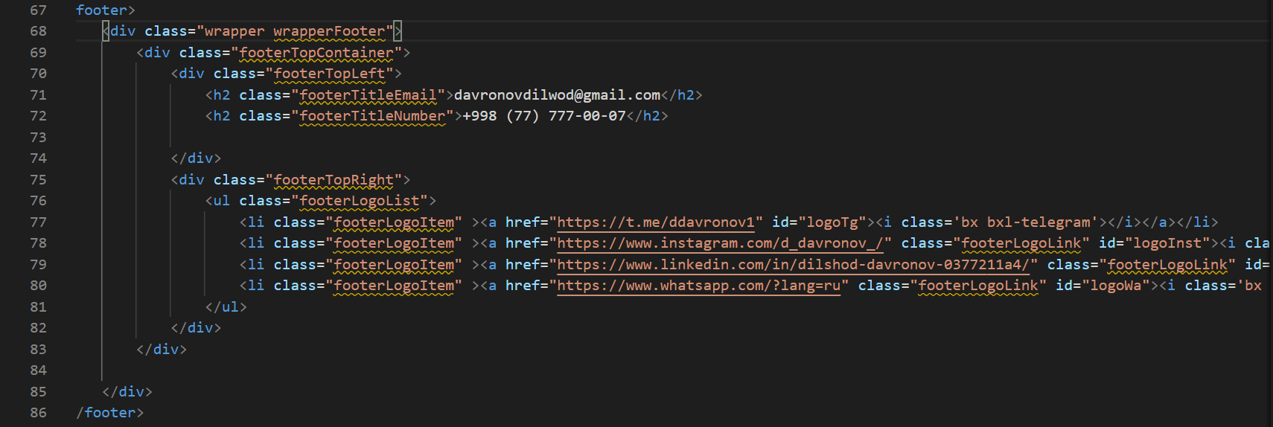

Footer part. I have used pair tag **<footer>** for this part, that also provided by HTML5. I put another **wrapperFooter** class, because I have added another parameter. I have divided into two parts of footer. Left side is my number and Gmail, right side is for icons list (Telegram, Instagram, LinkedIn, WhatsApp) .

* **about.html**

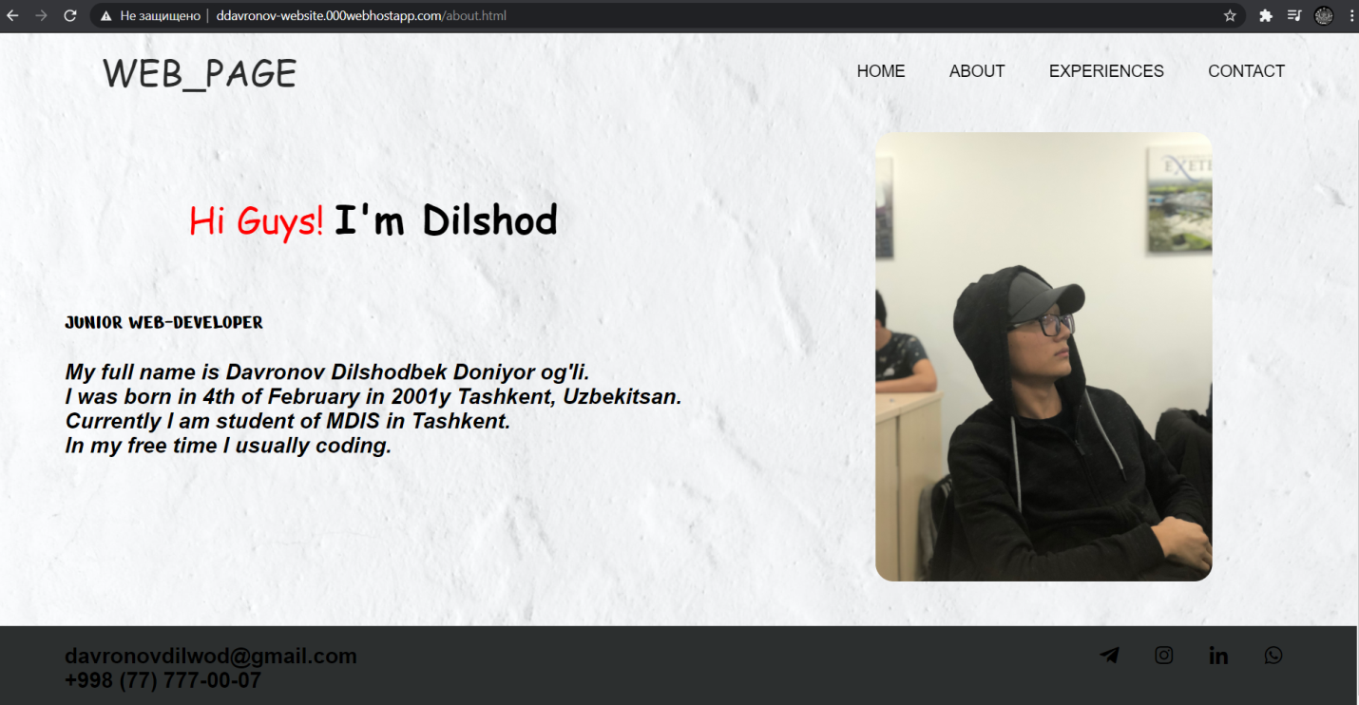

The next division of the page is the **about.html**. Introduce myself.

See figure below:

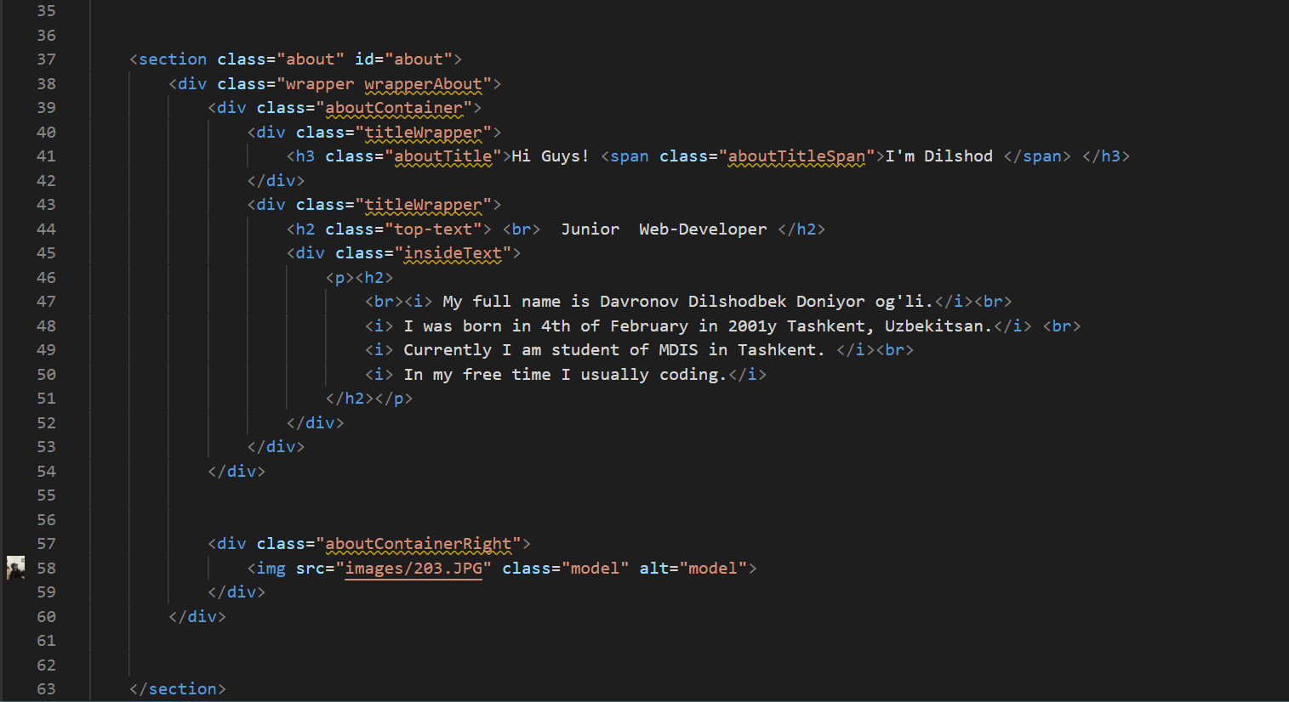

I will explain only **section** on this part. “**Section”** is about second page. I placed thecontent on the wrapper too. I have taken from Google white wallpaper and put it on the background. Additionally, I used my personal photo which is located near the text. I have written a short text about myself, and used tag **<i>** to make italic.style for the text**.** I wrote earlier that the pair tags <header> and <footer> are the same in all html folders.

* **work.html ( Experience )**

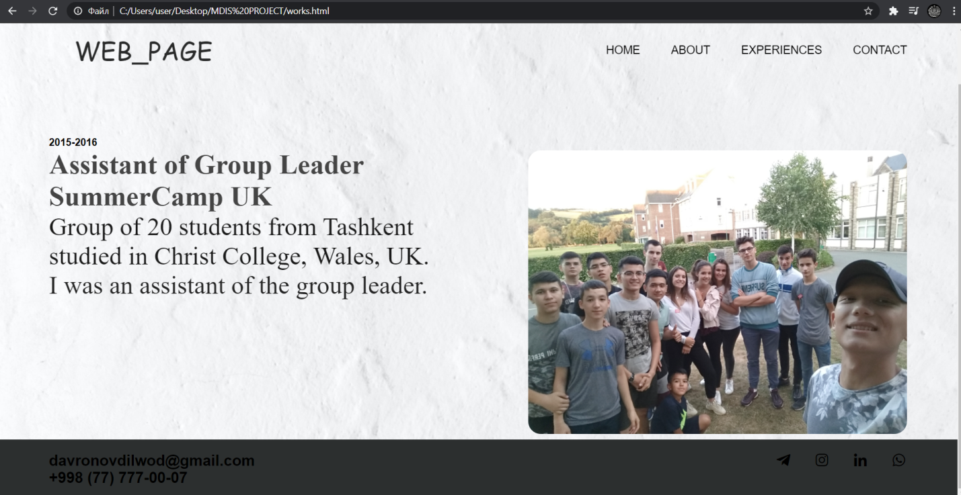

Check figure below :

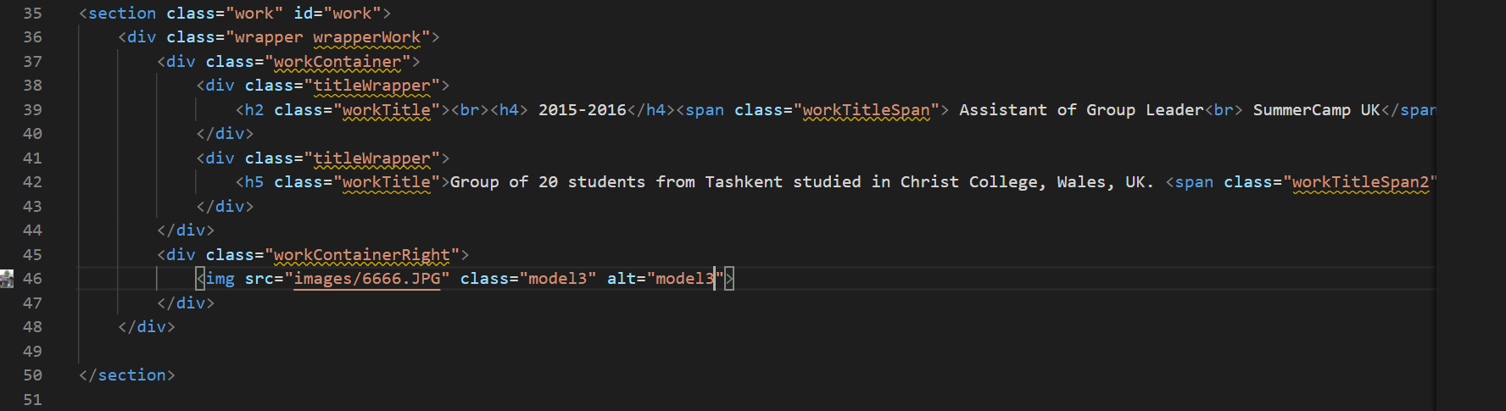

Skills.html folder. I have placed my experiences on the left side and the evidence photo on the right side. Obviously, I have separated **div** for the usage in CSS. I have written my experience text through the pair tag **<span>**  ( A <span> element which is used to color a part of a text )

**- contact.html**

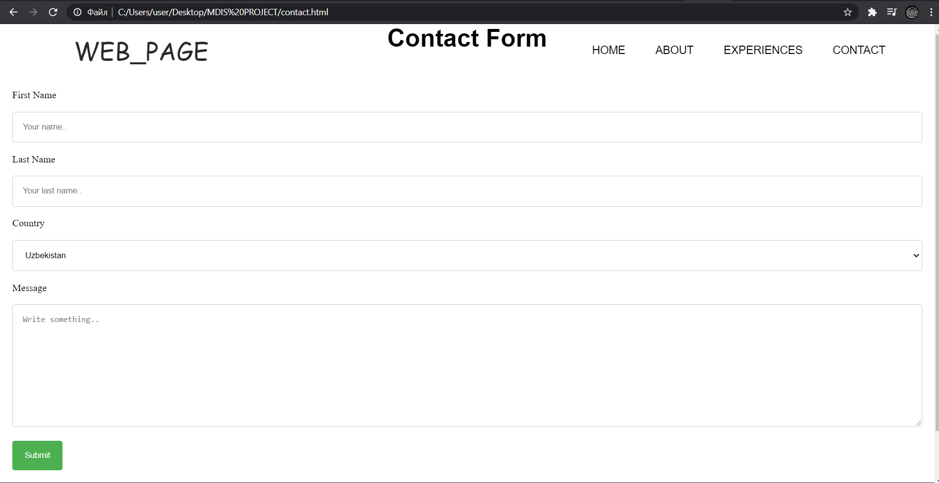

One of the hardest moments for me was to create this page although it might seem to be easy at first sight.

so let me try to explain contact.html page.

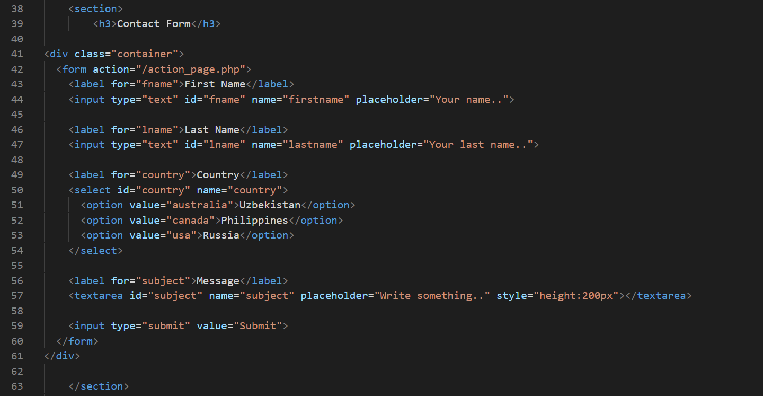

There are some tags which were new for me. The **<label>** tag establishes a link between a special label, which is usually text, and a form element **(<input>, <select>, <textarea>).** I used it in order to change the values ​​of the elements when the mouse is pressed over the text.

In addition, using **<label>** I can use keyboard shortcuts and jump to the active element of links.

There are two ways to link an object and a label. The first is to use an identifier inside the form and specify its name as an attribute for the **<label>** tag. In the second method, the form element is placed inside the **<label>** container.

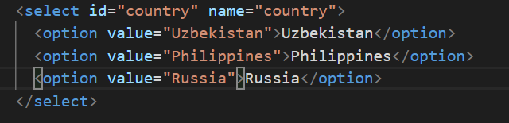

I used **<option>** tag that defines the individual items of the list created using the <select> container. The width of the list is determined by the widest text specified in the <option> tag, and can also be changed using styles. If you plan to send list data to the server, then you need to place the **<select>** element inside the form. This is also necessary when the list data is accessed through scripts.

**Google-Analytics**

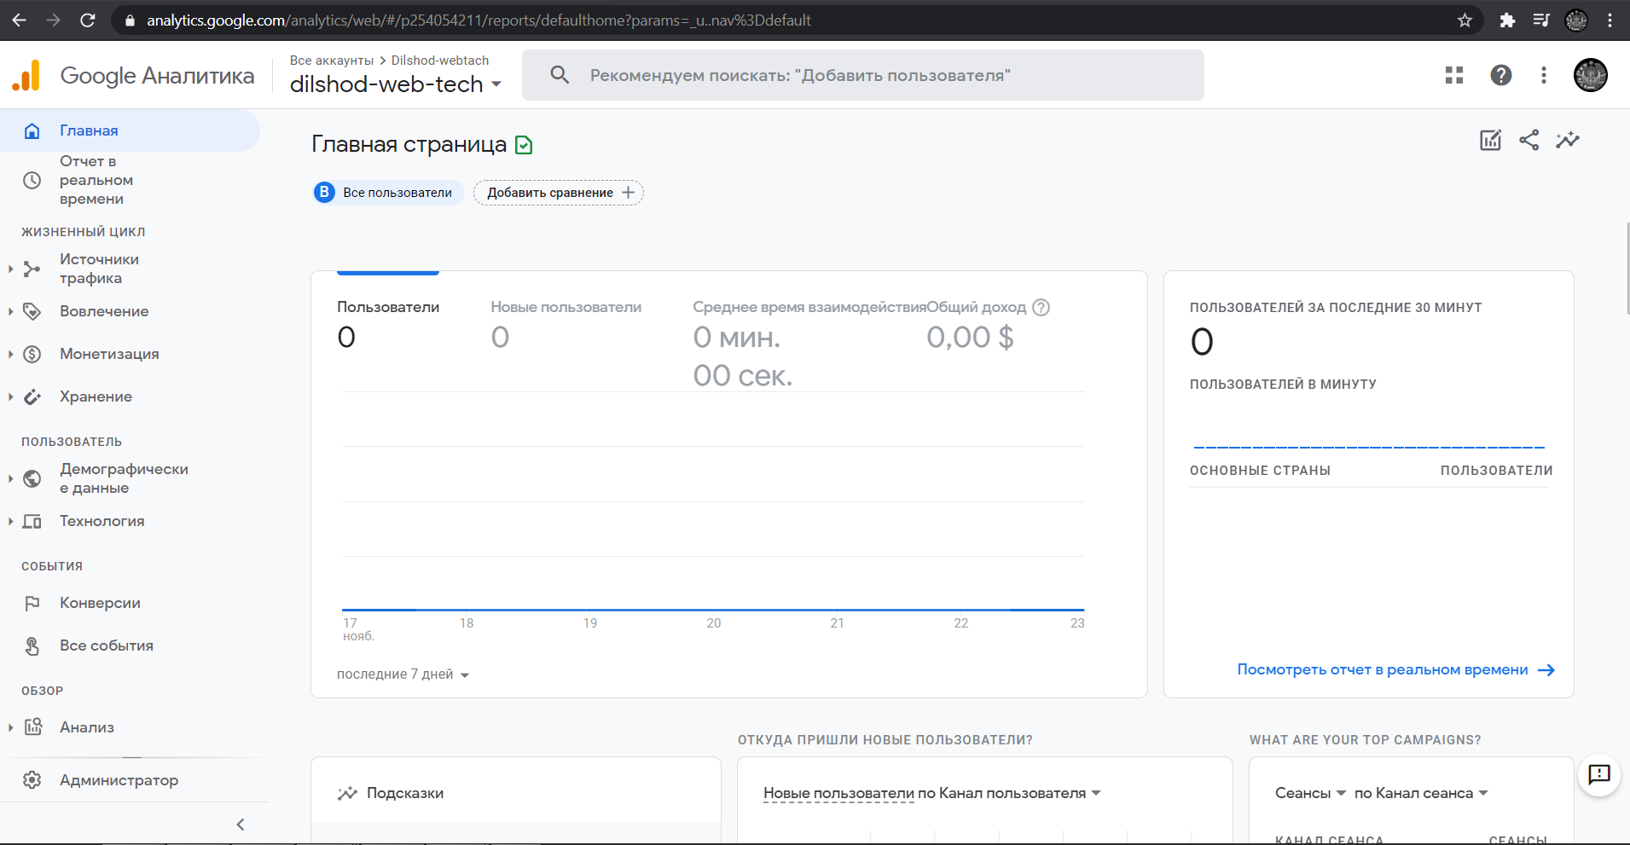

<!-- Global site tag (gtag.js) - Google Analytics -->

<script async src="https://www.googletagmanager.com/gtag/js?id=G-BH82JHGGDR"></script>

<script>

  window.dataLayer = window.dataLayer || [];

  function gtag(){dataLayer.push(arguments);}

  gtag('js', new Date());

  gtag('config', 'G-BH82JHGGDR');

</script>

**W3C. Validation step**

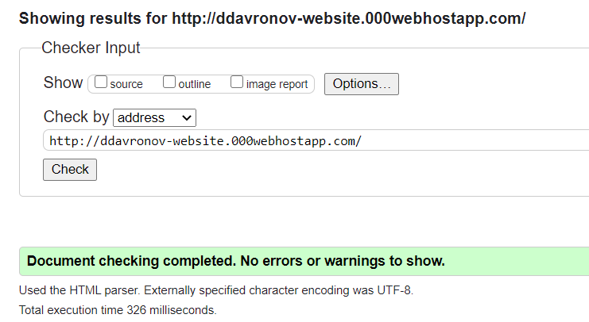

Style.CSS

## Add some basic layout CSS

Once we’re done with our HTML, it’s time to move on to CSS! The first and most important part to focus on is to get it looking like our layout - then we can focus on the details.

This means that we need to focus on properties like width, height, margin, padding, position, and display. Also, we need to make sure the images are the right size so that they don’t obliterate the page.

Here is the CSS that we will add to our style.css.

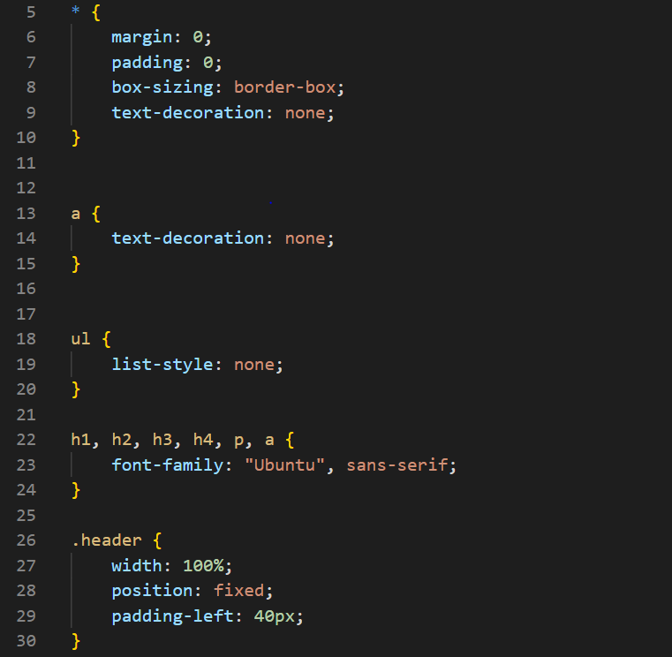

I am only added styles to make our overall layout look similar - not the individual content.

I make sure that the sections are set to 100% viewport **height**, make the header have a fixed position, **position** the items in the header, and more. after we are only adding styles to make our overall layout look similar - not the individual content. I made sure that the sections are set to 100% viewport height, made the header have a fixed position,

position the items in the header, and more. I also used flexboxes to center the content in our sections. I also used flexboxes to center the content in our sections.

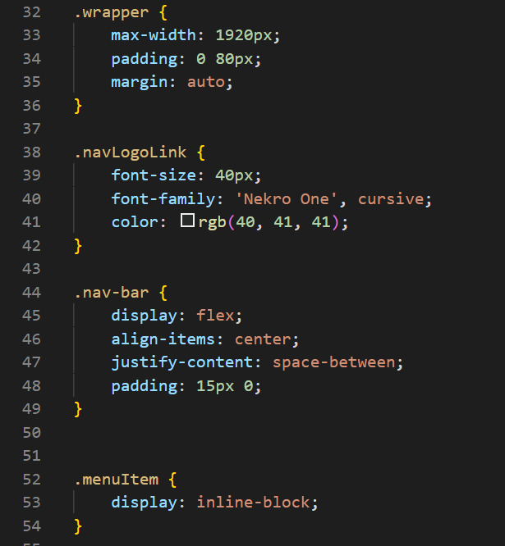

Navbar styling. I set size, margin and transition time for text. I did it flex, because I adapt to work with flex, and I think it is easier usage. We can place containers as we want, that can give us more profit on the adapting process. 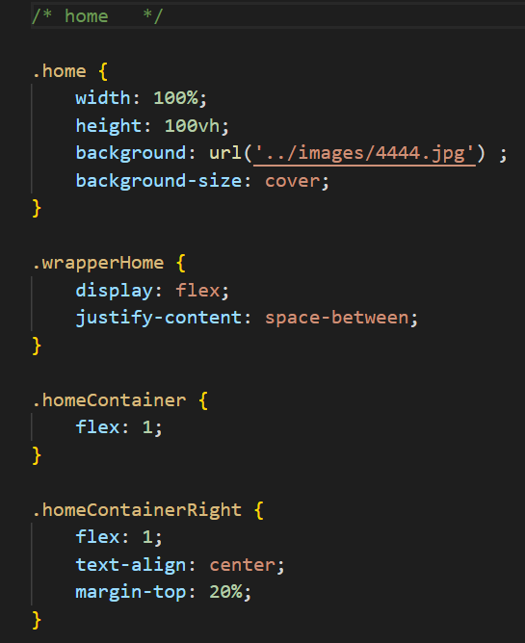

home styling .

pictures have been imported from images folder. I set color, sizes, weight and margins to the text.

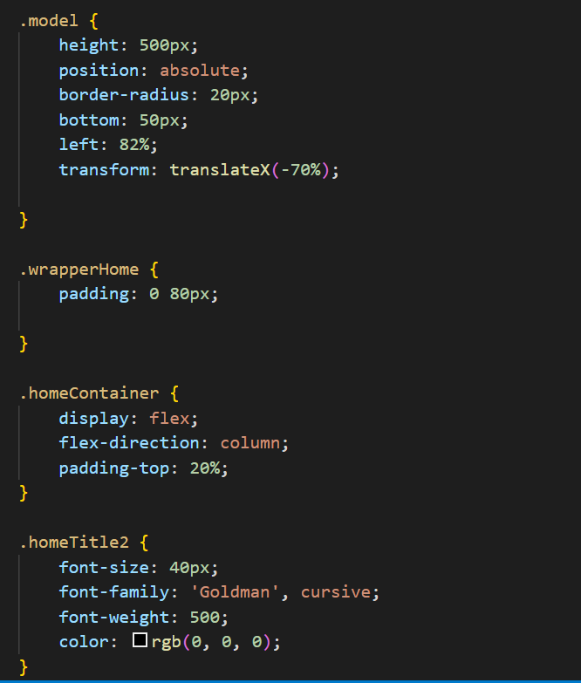

I have corrected the coordinates of the photo and homeTitle and given the size and insert.

The reason for the linear-gradient(rgba)before the url('image.jpg') is because otherwise the text is hard to read - so we add a semi-transparent white overlay ontop.

**about.html page styling**

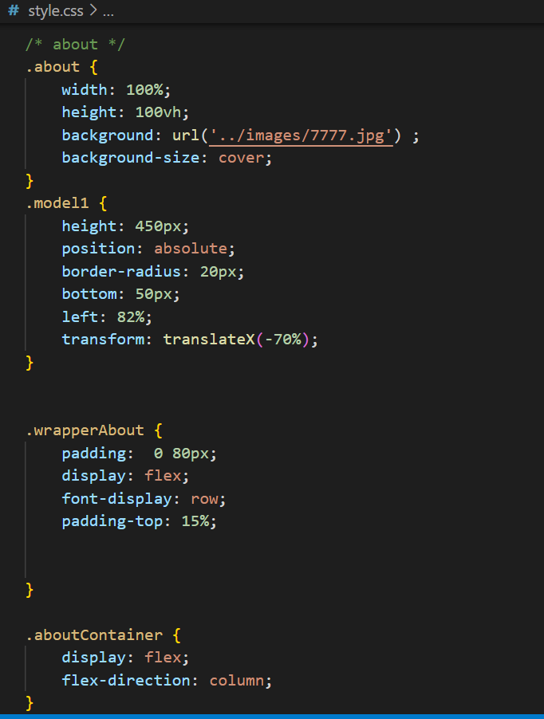

set coordinate for img and here is also put **flex.** wrapperAbout: flex,row.

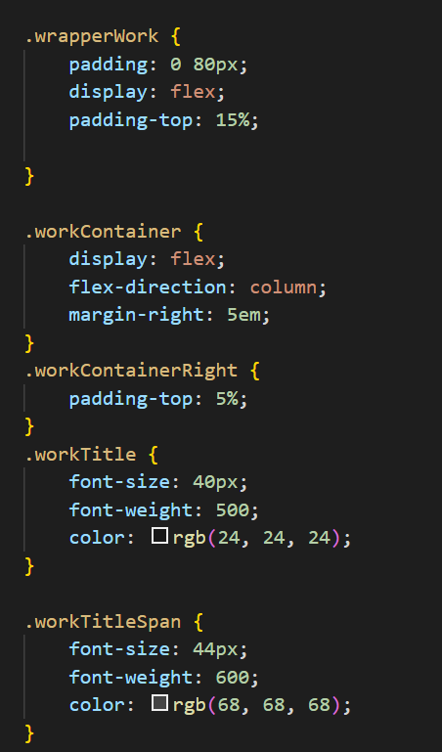

As you can see, we’ve added some general [**background styles**](https://codetheweb.blog/advanced-background-images/) to the section elements, as well as adding a background-image to each section individually.

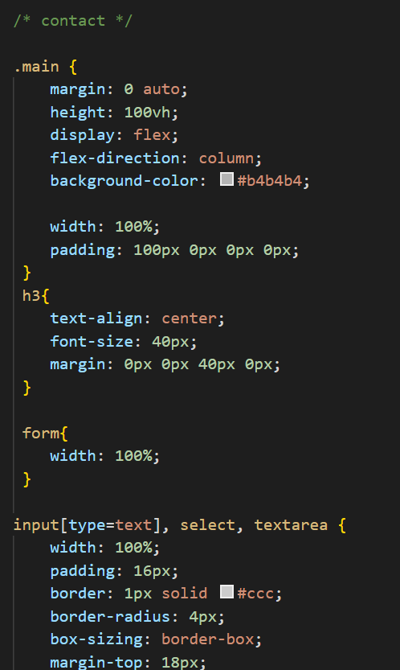

I used **border-radius** that property defines the radius of the element's corners.

The **box-sizing** property allows me to include the padding and border in an element's total width and height.

If you set box-sizing: border-box; on an element, padding and border are included in the width and height:

Select and style a link when you mouse over it

The :hover selector is used to select elements when you mouse over them.

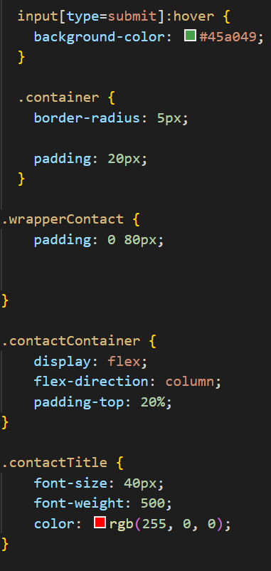

## Add colors and backgrounds

This is what will make our site look really awesome.

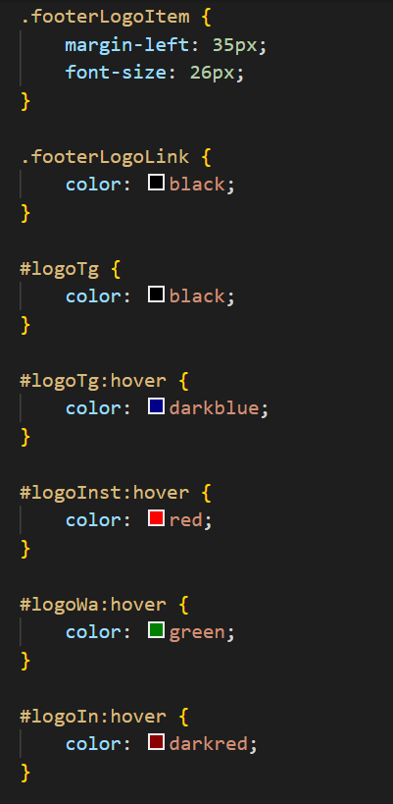

## Add colors and backgrounds

This is what will make our site look really awesome.